GE23131-Programming Using C-2024

Roll No : 240801145
Name : KAMESH . J

Week 2-2 :
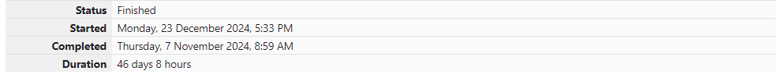
Problem 1:
Goki recently had a breakup, so he wants to have some more friends in his life. Goki has N people who he can be friends with, so he decides to choose among them according to their skills set Yi(1<=i<=n). He wants atleast X skills in his friends. Help Goki find his friends.

Input Format
First line contains a single integer X - denoting the minimum skill required to be Goki's friend. Next line contains one integer Y - denoting the skill of the person.

Output Format
Print if he can be friend with Goki. 'YES' (without quotes) if he can be friends with Goki else 'NO' (without quotes).

Constraints
1<=N<=1000000 1<=X,Y<=1000000

SAMPLE INPUT 1
100
110

SAMPLE OUTPUT 1
YES

CODE:
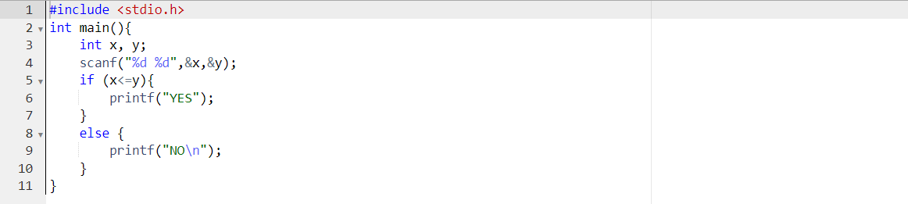

OUTPUT:
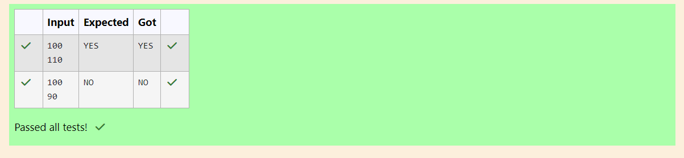

Problem 2:
Before the outbreak of corona virus to the world, a meeting happened in a room in Wuhan. A person who attended that meeting had COVID-19 and no one in the room knew about it! So, everyone started shaking hands with everyone else in the room as a gesture of respect and after meeting unfortunately everyone got infected! Given the fact that any two persons shake hand exactly once, can you tell the total count of handshakes happened in that meeting?
Say no to shakehands. Regularly wash your hands. Stay Safe.

Input Format
Read an integer N, the total number of people attended that meeting.

Output Format
Print the number of handshakes.

Constraints
0 < N < 106

SAMPLE INPUT 1
1

SAMPLE OUTPUT
0

CODE:
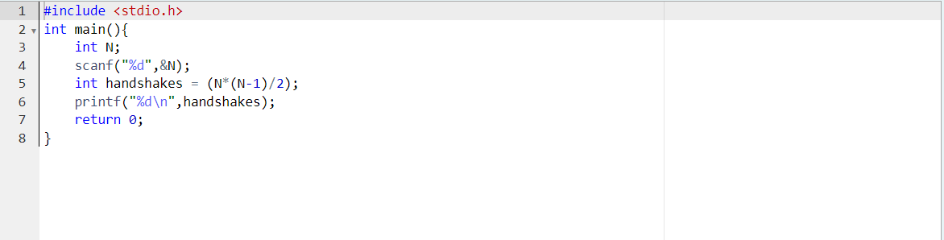

OUTPUT:
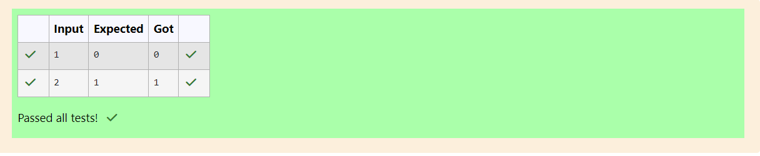

Problem 3:
In our school days, all of us have enjoyed the Games period. Raghav loves to play cricket and is Captain of his team. He always wanted to win all cricket matches. But only one last Games period is left in school now. After that he will pass out from school.
So, this match is very important to him. He does not want to lose it. So he has done a lot of planning to make sure his teams wins. He is worried about only one opponent - Jatin, who is very good batsman.
Raghav has figured out 3 types of bowling techniques, that could be most beneficial for dismissing Jatin. He has given points to each of the 3 techniques.
You need to tell him which is the maximum point value, so that Raghav can select best technique.
3 numbers are given in input. Output the maximum of these numbers.
Input Format:
Three space separated integers.

Output Format:
Maximum integer value

SAMPLE INPUT
8 6 1

SAMPLE OUTPUT
8
CODE:
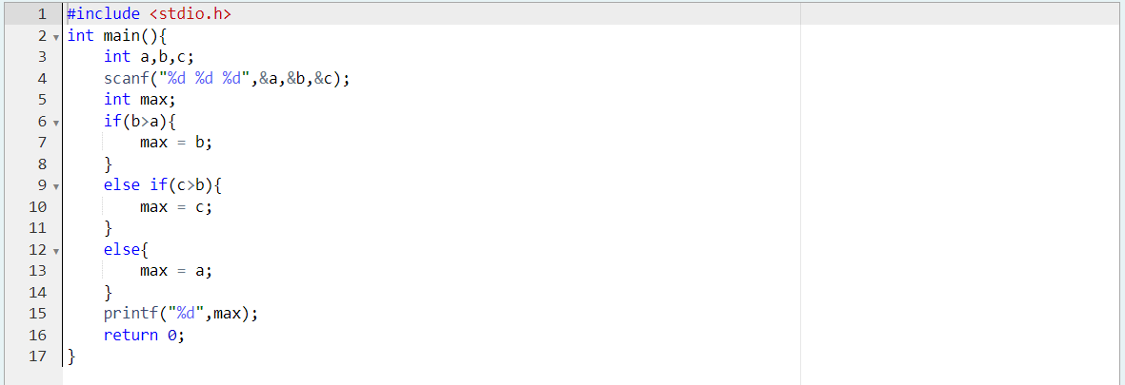

OUTPUT:
